
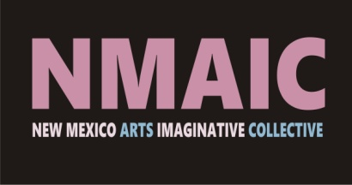

Doorway to Imagination: A Multi-sensory Approach to Art
Orpheum Community Hub- 500 2nd St. SW, October 4th - November 1st, 2024
Opening Reception: October 4th 5:30-8:00 PM
Closing Reception: November 1st, 5:00-7:00 PM

List of Gallery Art
Gallery is open by appointment: Monday through Friday, 9:00 AM-5:00 PM
Call: 505-243-6566
Please contact the artist by email to purchase.

Martha Anderson
TOUCHING SPACE
Each sculpture $300.00
Contact: mja.herart@yahoo.com
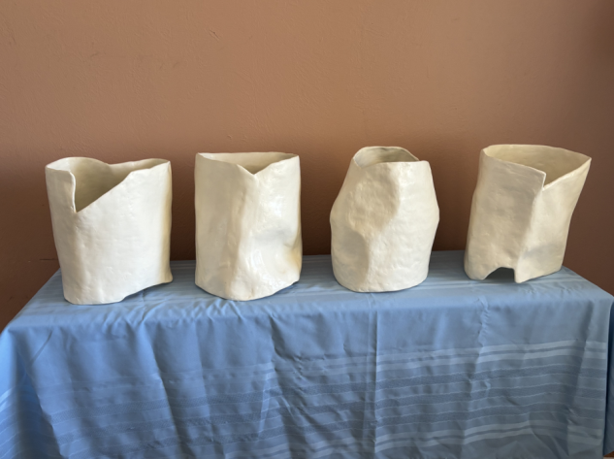

Nova DeNise Nova DeNise
DEER WOMAN TURTLES CALLING SELKIE HOME
Sculpture Relief
$450.00 $750.00

Contact: alexander7915@gmail.com Contact: alexander7915@gmail.com
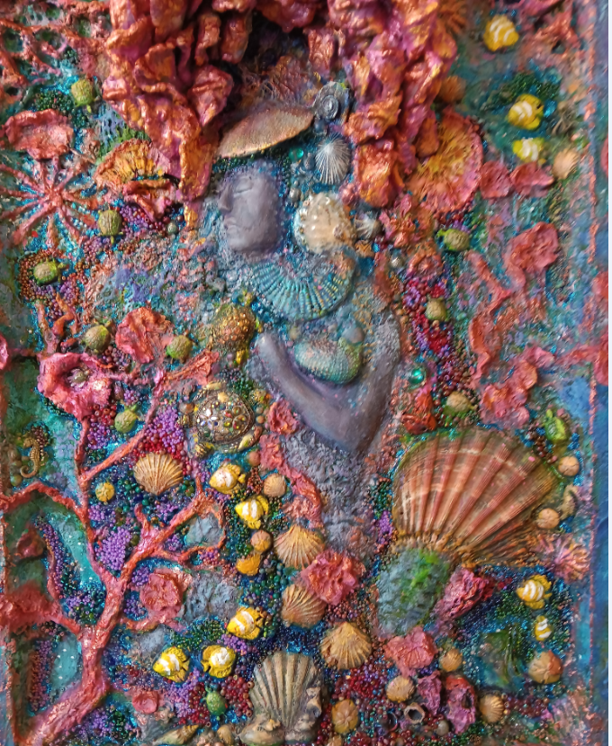
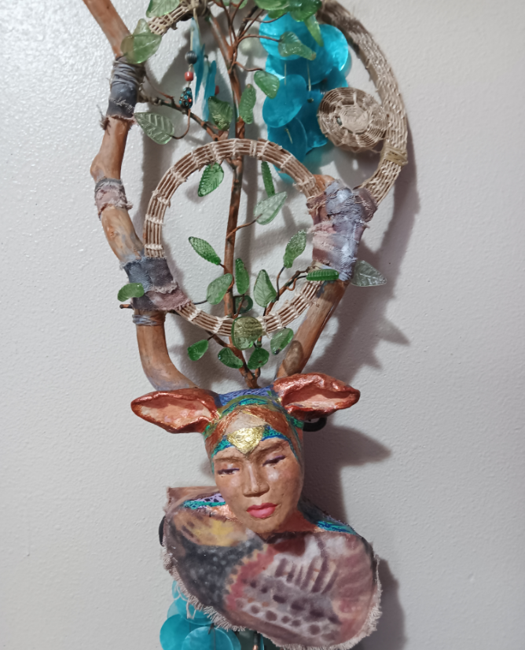

Stephanie Galloway
WONDERLAND
An aquarium filled with creatures sculpted
with scented air dry clay in a magical setting.
Also, a cassette tape with environmental
sounds can be played on a cassette recorder.
$150.00

Contact: talula7@gmail.com
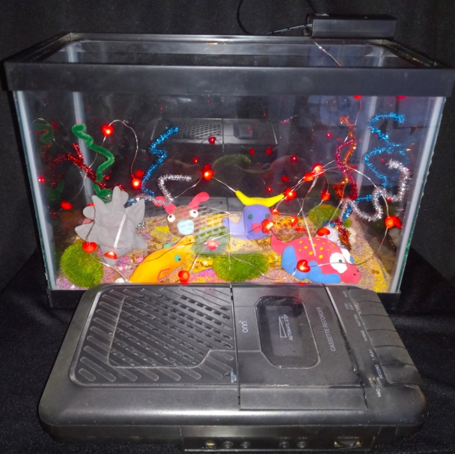

Stephanie Galloway
MAGNETIC PERSONALITY
Magnetic art (creatures made on magnetic sheets and
cut out to be used on a magnetic board)
$100.00

Contact: talula7@gmail.com
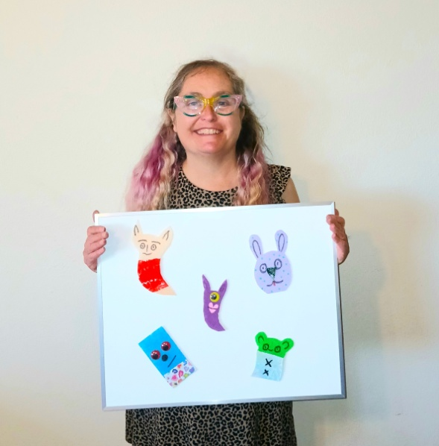

Caroline LeBlanc Caroline Le Blanc
DESERT NIGHT LILLITH
Knitted decorative apron with star and wolf trinkets Drum
$150.00 $450.00
Contact: wildernessheart@msn.com Contact: wildernessheart@msn.com
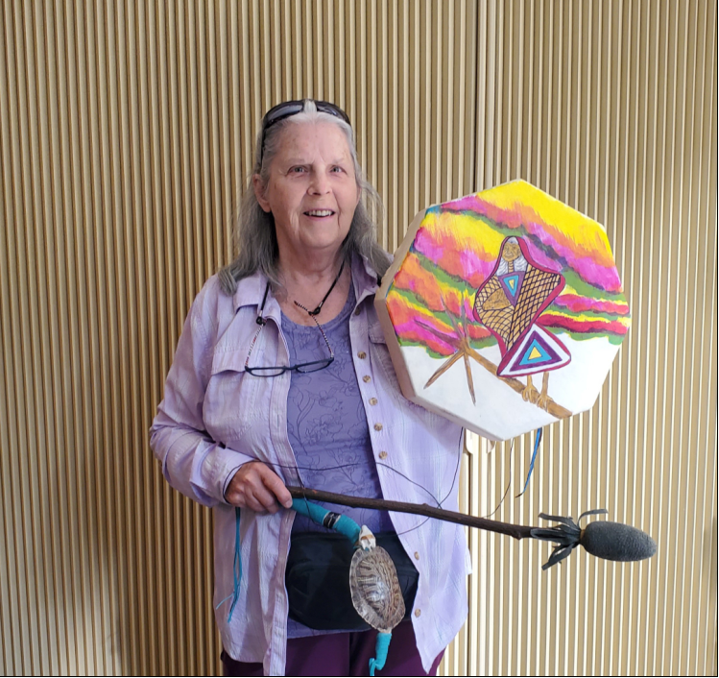
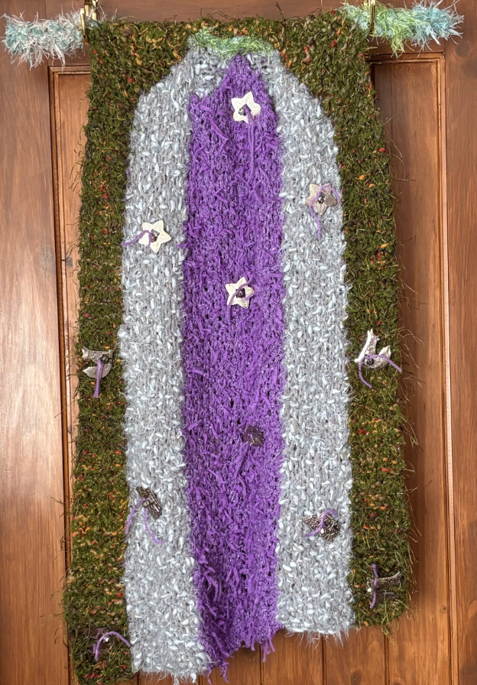

Caroline LeBlanc Caroline LeBlanc
DESERT HOMES HOMES FOR ALL
Painted Tyvec work suit with Milagros Knitted decorative apron with house
trinkets and bells
$100.00 $150.00
Contact: wildernessheart@msn.com Contact: wildernessheart@msn.com
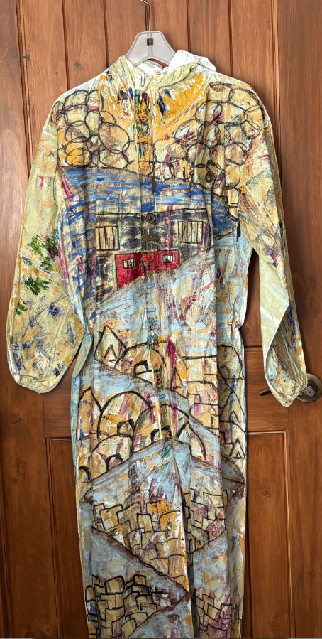
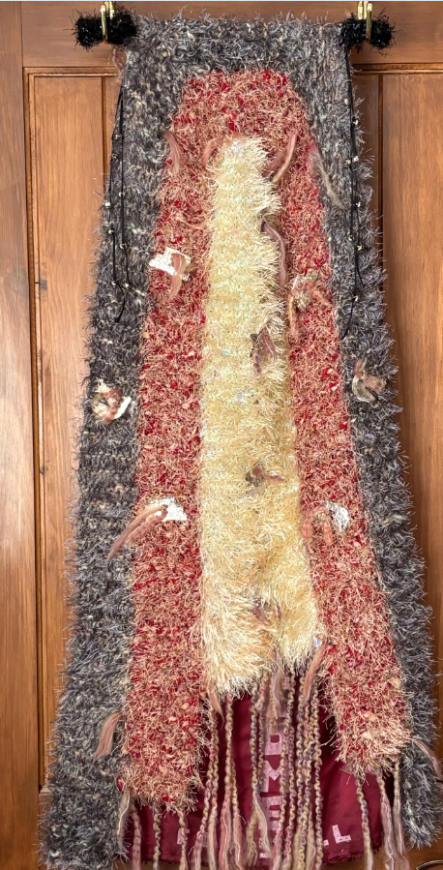

Caroline LeBlanc
OUT OF CHAOS, THE DANCING STAR
Fabric collage on board
$100.00
Contact: wildernessheart@msn.com
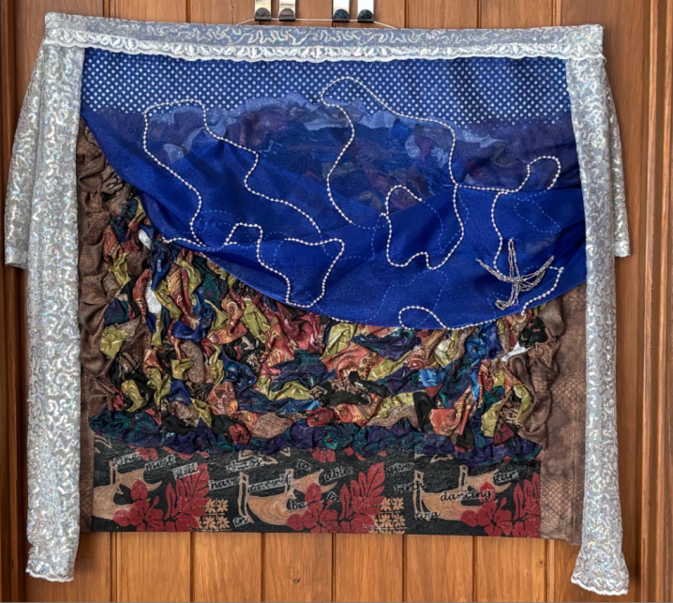

Bonnie K. Rucobo Bonnie K. Rucobo
BLUE HERON TIME OUT
Photograph Photograph
$45.00 $45.00
Contact: mechistle@gmail.com Contact: mechistle@gmail.com

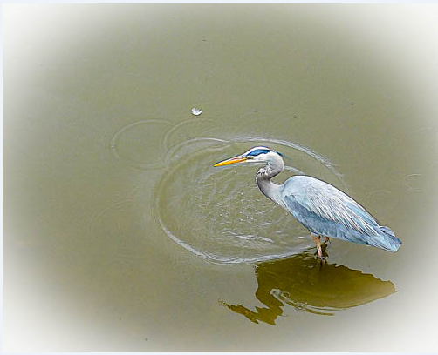
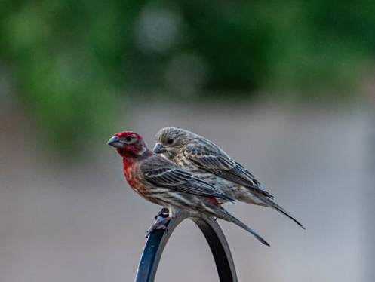

Bonnie K. Rucobo Bonnie K. Rucobo
LEAF GLOW HEADSTAND
Photograph Photograph
$45.00 $45.00
Contact: mechistle@gmail.com Contact: mechistle@gmail.com

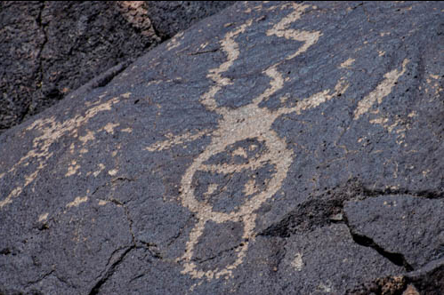
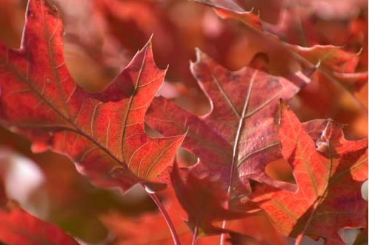

Bonnie K. Rucobo
CAMOUFLAGE
Photograph
$45.00
Contact: mechistle@gmail.com
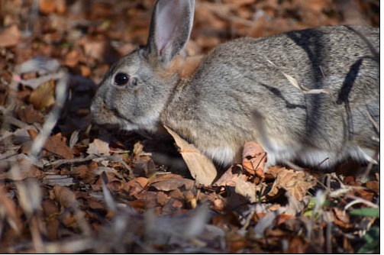

Anne Cole
THE LAST AMERICAN
Bronze Sculpture
NFS
Contact: anne@annecoleviolinmaker.com
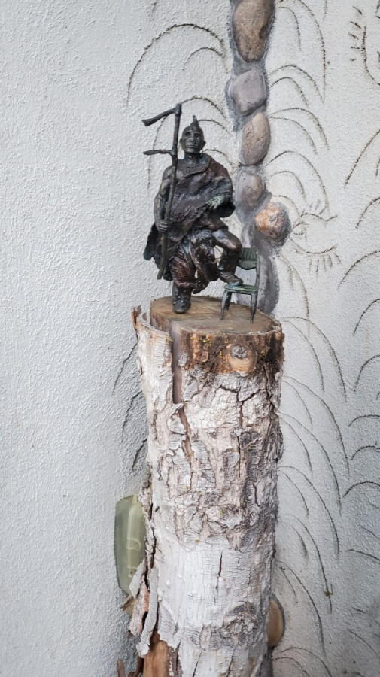

Karen Cunningham and Paul “Bill” Beck Karen Cunningham and Paul “Bill” Beck
HANDS ON NO AI HERE
Mythological size Panpipe Sculpture: Bamboo, 3D geometric shapes and handmade
electronic keyboard, electronics, metal frame, tin non-geometric shapes on a magnetic
sheet.

NFS NFS
Contact: emds_yes@juno.com Contact: emds_yes@juno.com
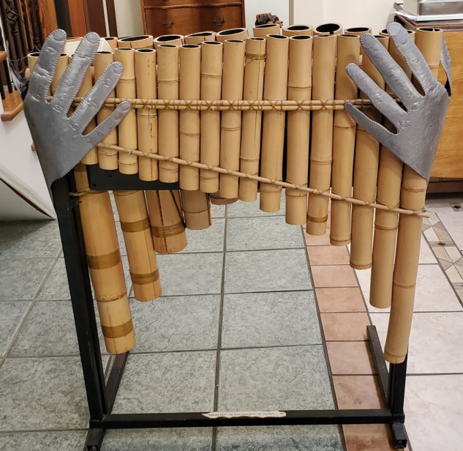
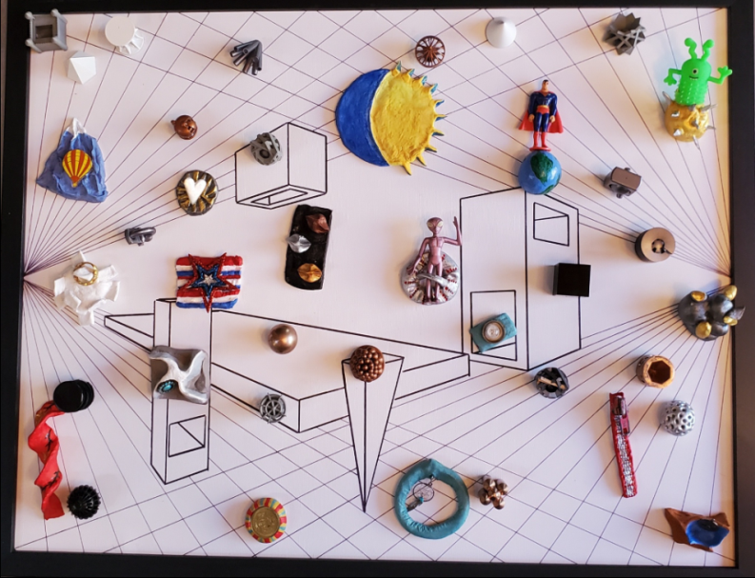

Karen Cunningham and Paul “Bill” Beck Karen Cunningham and Paul “Bill” Beck
I CAN HEAR… SIRENS IN THE ODYSSEY
Papier Mache Conch Shell Sculpture, acrylic, Papier Mache Conch Shell Sculpture,
decoupage, inorganic materials, sea shells acrylic, decoupage, inorganic materials, and recording devise. sea shells and recording devise.
NFS NFS
Contact: emds_yes@juno.com Contact: emds_yes@juno.com

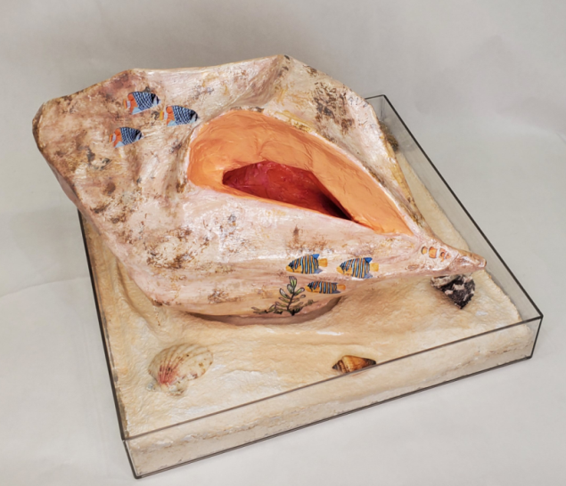
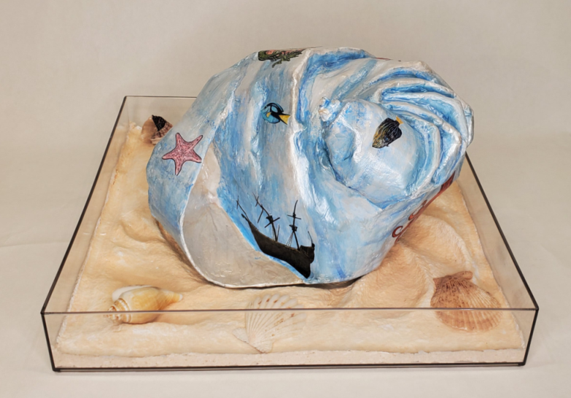

Karen Cunningham
RONDO-VOUS
Music Video- Length 4:00
NFS
Contact: emds_yes@juno.com

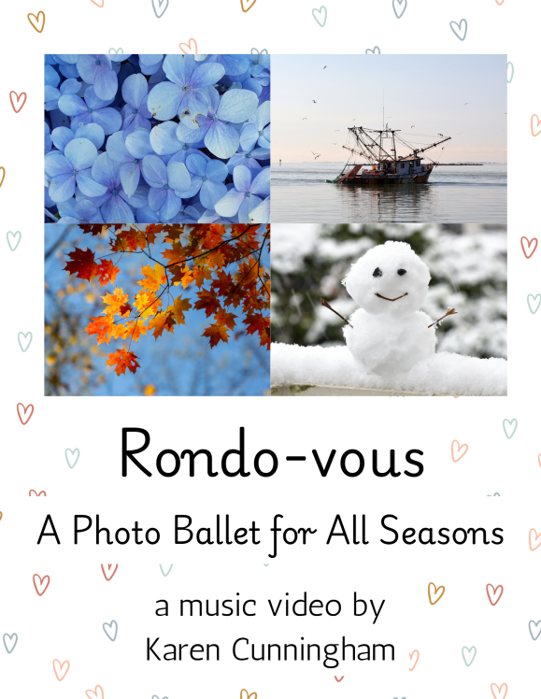

David Liggera David Liggera
MOSES SAILBOAT ON THE MEDITERRANEAN
Photograph Photograph
NFS NFS
Contact: dj22310@gmail.com Contact: dj22310@gmail.com
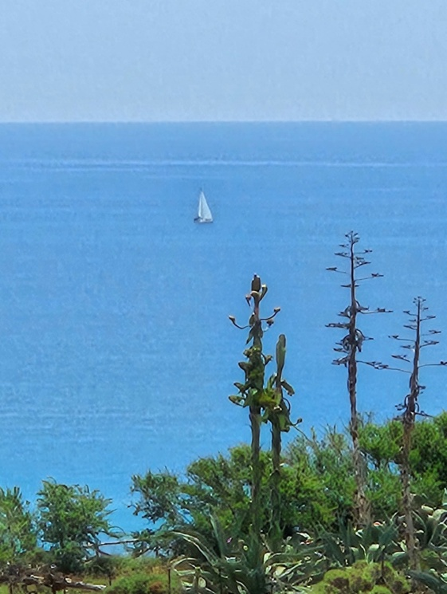
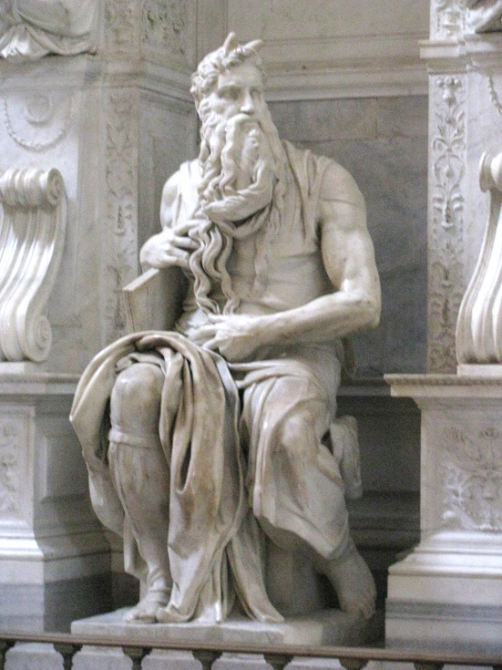

David Liggera
CALTABELLOTTA
Photograph NFS
Contact: dj22310@gmail.com
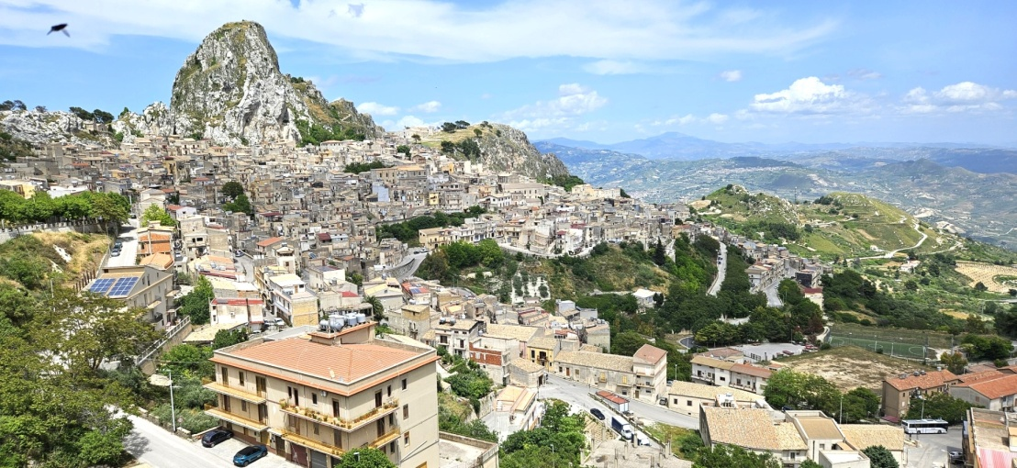

David Liggera
SCALA DEI TURCHI
Photograph
NFS
Contact: dj22310@gmail.com
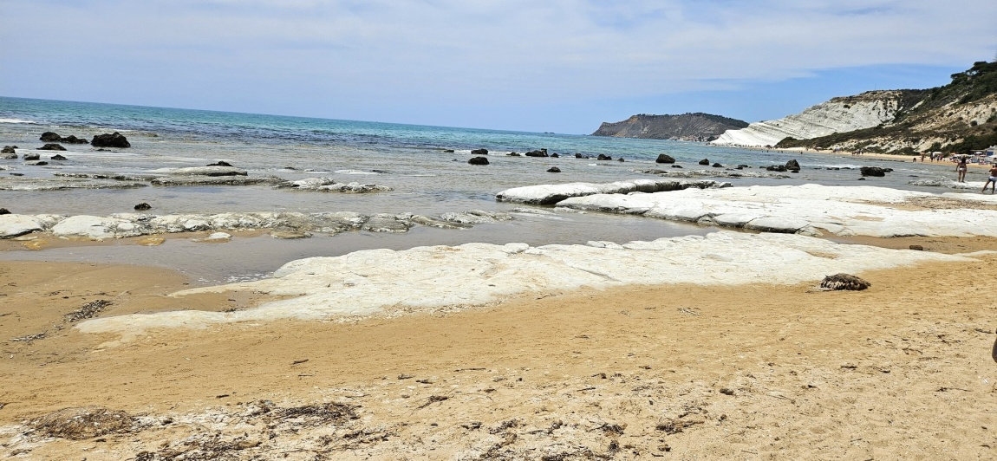

David Liggera
THE COLOSSEUM
Photograph
NFS
Contact: dj22310@gmail.com
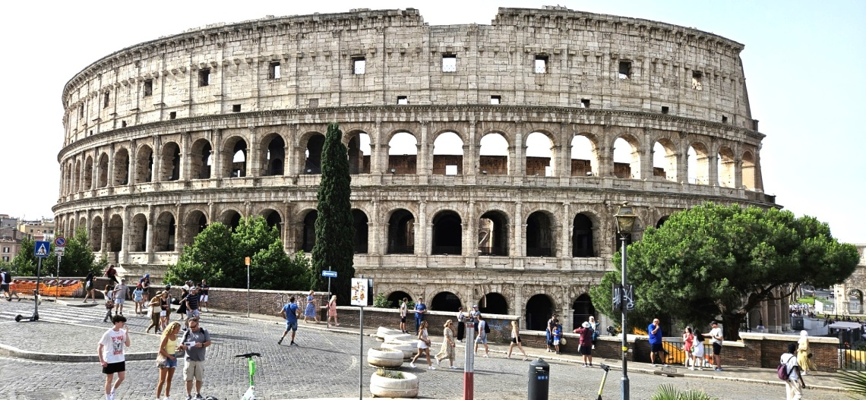

Jeff Hudson
FEEL FREE TO TOUCH
Experimental film- Length: 4:00
NFS
Contact: jeffhudson587@comcast.net
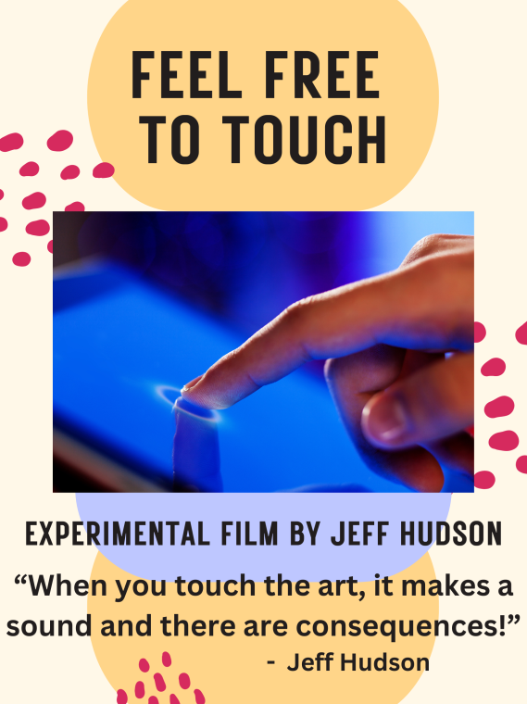

Danny Manweller
AUTUMN OVER THE RIO GRANDE
Drone video- Length: 5:26
NFS
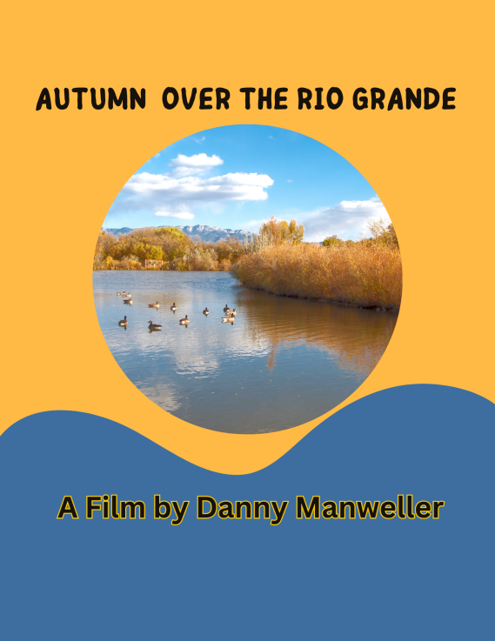
Contact: Djmabq@msn.com

